**GUJARAT TECHNOLOGICAL UNIVERSITY**

Chandkheda, Ahmedabad

Affiliated



SHANTILAL SHAH ENGINEERING COLLEGE

A Report On-

SMART MANAGEMENT OF COLLEGE DATA USING CLOUD ENVIRONMENT

Under subject of

DESIGN ENGINEERING – 2B

B. E. III, Semester – VI

INFORMATION & TECHNOLOGY

Submitted by:

Group:

Sr. Name of student Enrolment No.

1. Krupali Mangroliya 130430116053
2. Ghanta Sarfaraz 130430116031
3. Devganiya Seema 130430116024
4. Jadeja Harshvardhansinh 130430116043
5. Hadiya Riya 130430116040

**A.D.Meniya**

(Faculty Guide)

**Prof. B. V. Buddhdev**

Head of the Department

Academic year

(2015-2016)



**CERTIFICATE**

This is to certify that the work embodied in this thesis entitled “**SMART MANAGEMENT OF COLLEGE DATA USING CLOUD ENVIRONMENT”** was carried out by **Krupali Mangroliya (130430116053)** at **Information Technology Department** of **Shantilal Shah Engineering College, Bhavnagar** in Partial Fulfilment of the Requirements for the Degree of B.E. to be awarded by Gujarat Technological University. This work has been carried out under my supervision and it is up to my satisfaction.

Date:

Place: Bhavnagar

|  |  |  |
| --- | --- | --- |
| **ProfA.D.Meniya**  Asst. Professor(IT),  SSEC ,Bhavnagar |  | **Prof. B. V. Buddhdev**  HOD,  Information Technology Department  SSEC ,Bhavnagar |



**CERTIFICATE**

This is to certify that the work embodied in this thesis entitled “**SMART MANAGEMENT OF COLLEGE DATA USING CLOUD ENVIRONMENT”** was carried out by **Ghanta Sarfaraz(130430116031)**at **Information Technology Department** of **Shantilal Shah Engineering College, Bhavnagar** in Partial Fulfilment of the Requirements for the Degree of B.E. to be awarded by Gujarat Technological University. This work has been carried out under my supervision and it is up to my satisfaction.

Date:

Place: Bhavnagar

|  |  |  |
| --- | --- | --- |
| **ProfA.D.Meniya**  Asst. Professor(IT),  SSEC ,Bhavnagar |  | **Prof. B. V. Buddhdev**  HOD,  Information Technology Department  SSEC ,Bhavnagar |



**CERTIFICATE**

This is to certify that the work embodied in this thesis entitled “**SMART MANAGEMENT OF COLLEGE DATA USING CLOUD ENVIRONMENT”** was carried out by **Devganiya Seema (130430116024)**at **Information Technology Department** of **Shantilal Shah Engineering College, Bhavnagar** in Partial Fulfilment of the Requirements for the Degree of B.E. to be awarded by Gujarat Technological University. This work has been carried out under my supervision and it is up to my satisfaction.

Date:

Place: Bhavnagar

|  |  |  |
| --- | --- | --- |
| **ProfA.D.Meniya**  Asst. Professor(IT),  SSEC ,Bhavnagar |  | **Prof. B. V. Buddhdev**  HOD,  Information Technology Department  SSEC ,Bhavnagar |



**CERTIFICATE**

This is to certify that the work embodied in this thesis entitled “**SMART MANAGEMENT OF COLLEGE DATA USING CLOUD ENVIRONMENT”** was carried out by **Jadeja Harshvardhansinh (130430116043)** at **Information Technology Department** of **Shantilal Shah Engineering College, Bhavnagar** in Partial Fulfilment of the Requirements for the Degree of B.E. to be awarded by Gujarat Technological University. This work has been carried out under my supervision and it is up to my satisfaction.

Date:

Place: Bhavnagar

|  |  |  |
| --- | --- | --- |
| **ProfA.D.Meniya**  Asst. Professor(IT),  SSEC ,Bhavnagar |  | **Prof. B. V. Buddhdev**  HOD,  Information Technology Department  SSEC ,Bhavnagar |



**CERTIFICATE**

This is to certify that the work embodied in this thesis entitled “**SMART MANAGEMENT OF COLLEGE DATA USING CLOUD ENVIRONMENT”** was carried out by **Hadiya Riya (130430116040)**at **Information Technology Department** of **Shantilal Shah Engineering College, Bhavnagar** in Partial Fulfilment of the Requirements for the Degree of B.E. to be awarded by Gujarat Technological University. This work has been carried out under my supervision and it is up to my satisfaction.

Date:

Place: Bhavnagar

|  |  |  |
| --- | --- | --- |
| **ProfA.D.Meniya**  Asst. Professor(IT),  SSEC ,Bhavnagar |  | **Prof. B. V. Buddhdev**  HOD,  Information Technology Department  SSEC ,Bhavnagar |

**Acknowledgement**

We would like to place on record our deep sense of gratitude to Prof.**B.V.BUDHDEV**, HOD-Dept. of Information & Technology Engineering, SSEC, Bhavnagar, for his generous guidance, help and useful suggestions.

We express our sincere gratitude to Prof.**A.D.Meniya**, Dept. of Information & Technology Engineering, SSEC, Bhavnagar, for her stimulating guidance, continuous encouragement and supervision throughout the course of present work.

We also wish to extend our thanks to our family and other colleagues for attending our seminars and for their insightful comments and constructive suggestions to improve the quality of this report work.

**Signature(s) of Students**

**Krupali Mangroliya(130430116053)**

**Ghanta Sarfaraz (130430116031)**

**Devganiya Seema(130430116024)**

**Jadeja Harshvardhansinh(130430116043)**

**Hadiya Riya (130430116040)**

**Abstract**

Mostly in government colleges all data of students, Staff and other data are registered or stored in hardcopy. Due to which many time problem occurs like if any students or staff’s data is needed than the person or department who is managing this data have to find data. Sometime it occurs like file containing data is misplaced or damaged by any human and natural hazards so we are creating a cloud storage to store these data.

**INDEX**

1. Introduction……………………………………………………....**1**
2. Literature review……………………………………………….....**2**
3. Previous project sheet views……………………………………....**3**
   1. Product development canvas (PDC)……………………….....
   2. Ideation canvas(IC)………………………………….............
   3. Empathy mapping canvas……………………………………
   4. AEIOU canvas……………………………………………….

3.4.1. Activity sheet………………………………………..

3.4.2. Environment sheet…………………………………..

3.4.3. Interaction sheet……………………………………..

3.4.4. Object sheet ………………………………………….

3.4.5. User sheet……………………………………………..

3.5. Learning need matrix (LNM)………………………………..

1. Design consideration for detail design part………………………..**13**
   1. Feasibility study………………………………………..........
   2. Design for Performance, Safety and Reliability……………..
   3. Design for Ergonomics and Aesthetics……………………….
   4. Design for Manufacturability and Assembly (DFMA)……….
   5. Design for Cost, Environment………………………………..
2. Design calculation ………………………………………………….**20**
3. Measuring instruments/techniques-knowledge and use……………**22**
4. Comparison………………………………………………………....**23**
   1. Selection materials ……………………………………………..
   2. Tools and equipment’s for our project…………………………..
5. Analysis……………………………………………………………..**24**
6. Prototyping &Testing………………………………………….……**25**
   1. Prototyping……………………………………………………….

9.1.1. Cloud SIM……………………………………………..

9.1.2. Cloud SIM Architecture……………………………….

9.1.3. Features of Cloud SIM………………………………...

9.1.4. How to Install Cloud SIM in Window…………………

9.1.5. Virtualization…………………………………………....

* 1. Testing……………………………………………………………...

9.2.1. Keys for Useful Testing……………………………………...

1. Detail Design Calculation…………………………………………..**30**

10.1.Material Requirements………………………………………..

10.2.Standards ……………………………………………………..

10.3.Safty Rules…………………………………………………….

1. Design for Use, Reuse &Sustainability…………………………....**33**

11.1.Sustainability………………………………………………….

11.2.Maintanability………………………………………………...

11.3.Reusebility…………………………………………………….

11.4.Reliability……………………………………………………...

1. Video Prototype……………………………………………..……...**34**

12.1.Cloud SIM Installation Process………………………………..

1. Conclusion……………………………………………..…………...**35**
2. References…………………………………………..………………**36**
3. **Introduction**

Cloud Storage is a service where data is remotely maintained, managed, and backed up. The service is available to users over a network, which is usually the internet. It allows the user to store files online so that the user can access them from any location via the internet. The provider company makes them available to the user online by keeping the uploaded files on an external server. This gives companies using cloud storage services ease and convenience, but can potentially be costly. Users should also be aware that backing up their data is still required when using cloud storage services, because recovering data from cloud storage is much slower than local backup.

**How Cloud Storage Works?**

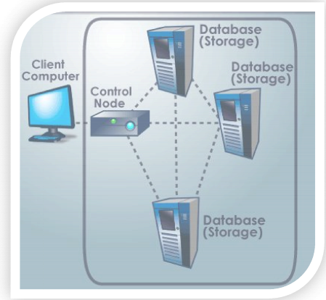

At the simplest level, cloud storage can just be one user with access to one server. A user would upload his data through a terminal and store it on a server for safe keeping. In a scenario where that server was to malfunction, retrieving your data files would be impossible task until that server came back online. From a customer standpoint, this system would be highly ineffective as it would be unreliable and consumers would reject such an unreliable product in the marketplace. For the idea of cloud storage to be a feasible business, the simplest level of cloud storage would have to be expanded immensely to address the issue of reliability.

Cloud storage is achieved through following the concepts of redundancy and repetition. Without these concepts, cloud storage would be very difficult, if not impossible to exist. Redundancy is really the core of cloud storage. Cloud storage at its basic level is just backing up data enough times so that the chance of losing that data becomes nearly irrelevant. Having multiple data servers to store data decreases the chances of losing data. A single data server store data is good, but ten data servers is a lot better.

Data centres are known to house several, even hundreds of data servers. Along with multiple data servers come multiple power supplies. Having all data servers on one power supply would counteract the use of having multiple servers. If one power supply were to power all the servers in a network, and for some reason it went offline, all the servers on that network would go down, rendering the entire network inaccessible. To combat this issue, servers are divided into groups and each is given their own power supply. By doing so, you lessen the chance of all your equipment going offline. Having multiples of equipment solves half the problem of cloud storage.

1. **Literature review**
2. **Cloud Storage as the Infrastructure of Cloud Computing**

**Abstract:**

As an emerging technology and business paradigm, Cloud Computing has taken commercial computing by storm. Cloud computing platforms provide easy access to a company’s high-performance commuting and storage infrastructure through web services. With cloud computing, the aim is to hide the complexity of IT infrastructure management from its users. At the same time, cloud computing platforms provide massive scalability, 99.999% reliability, high performance, and specifiable configurability. These capabilities are provided at relatively low costs compared to dedicated infrastructures. This article gives a quick introduction to cloud storage. It covers the key technologies in Cloud Computing and Cloud Storage, several different types of clouds services, and describes the advantages and challenges of Cloud Storage after the introduction of the Cloud Storage reference model.

**Ref:** School of Computer Science and Technology, Zhejiang University,2010 International Conference on Intelligent Computing and Cognitive Informatics.

1. **Toward Publicly Auditable Secure Cloud Data Storage Services**

**Abstract:**

Cloud computing is the long dreamed vision of computing as a utility, where data owners can remotely store their data in the cloud to enjoy on-demand high-quality applications and services from a shared pool of configurable computing resources. While data outsourcing relieves the owners of the burden of local data storage and maintenance, it also eliminates their physical control of storage dependability and security, which traditionally has been expected by both enterprises and individuals with high service-level requirements. In order to facilitate rapid deployment of cloud data storage service and regain security assurances with outsourced data dependability, efficient methods that enable on-demand data correctness verification on behalf of cloud data owners have to be designed. In this article we propose that publicly auditable cloud data storage is able to help this nascent cloud economy become fully established. With public auditability, a trusted entity with expertise and capabilities data owners do not possess can be delegated as an external audit party to assess the risk of outsourced data when needed. Such an auditing service not only helps save data owners’ computation resources but also provides a transparent yet cost-effective method for data owners to gain trust in the cloud. We describe approaches and system requirements that should be brought into consideration, and outline challenges that need to be resolved for such a publicly auditable secure cloud storage service to become a reality.

**Ref:** Cong Wang and KuiRen, Illinois Institute of Technology Wenjing Lou, Worcester Polytechnic Institute Jin Li, Illinois Institute of Technology,2010.

1. **Previous Project Views**

**3.1. Product Development Canvas**

**Advantages of Cloud Storage:**

**Usability–** All cloud storage services reviewed in this topic have desktop folders for Mac’s and

PC’s. This allows users to drag and drop files between the cloud storage and their local storage.

**Bandwidth –** You can avoid emailing files to individuals and instead send a web link to recipients through your email.

**Accessibility –** Stored files can be accessed from anywhere via Internet connection.

**Disaster Recovery –** It is highly recommended that businesses have an emergency back‐up plan ready in the case of an emergency. Cloud storage can be used as a back‐up plan by businessesby providing a second copy of important files. These files are stored at a remote location andcan be accessed through an internet connection.

**Cost Savings –** Businesses and organizations can often reduce annual operating costs by usingcloud storage; cloud storage costs about 3 cents per gigabyte to store data internally. Users cansee additional cost savings because it does not require internal power to store informationremotely.

**Disadvantages of Cloud Storage:**

**Usability –**Be careful when using drag/drop to move a document into the cloud storage folder.

This will permanently move your document from its original folder to the cloud storage location.

Do a copy and paste instead of drag/drop if you want to retain the document’s original locationin addition to moving a copy onto the cloud storage folder.

**Bandwidth –** Several cloud storage services have a specific bandwidth allowance. If anorganization surpasses the given allowance, the additional charges could be significant. However, some providers allow unlimited bandwidth. This is a factor that companies should consider when looking at a cloud storage provider.

**Accessibility –**If you have no internet connection, you have no access to your data.

**Data Security –**There are concerns with the safety and privacy of important data storedremotely. The possibility of private data commingling with other organizations makes somebusinesses uneasy.

**Software –** If you want to be able to manipulate your files locally through multiple devices, you'll need to download the service on all devices.

**Limitations of cloud storage:**

1. Vulnerability of attack
2. Limited control and flexibility
3. Cloud storage cost
4. Platform dependencies
5. Downtime

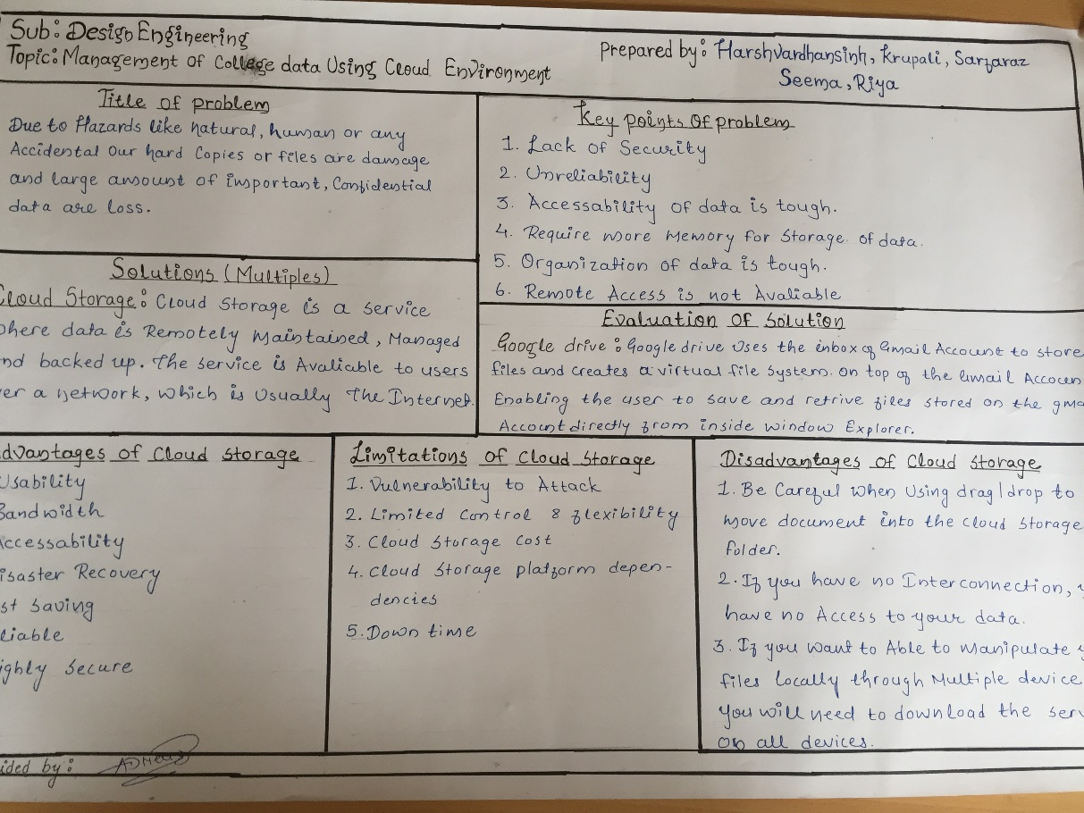

* 1. **Ideation canvas (IC)**

**People: Situations:**

1. Staff members 1. College campus
2. Students 2. Home
3. Principal 3. Anywhere
4. Head of dept. 4. University

**Activities**: **Purpose**:

1. Make own Ppt. 1. Get information
2. Making word file 2. Storing of data
3. Storing data 3. Data retrieving
4. Provide security 4. To reduce the effort the hardware
5. Data upload 5. User friendly
6. Retrieve data
7. Upload images
8. Information

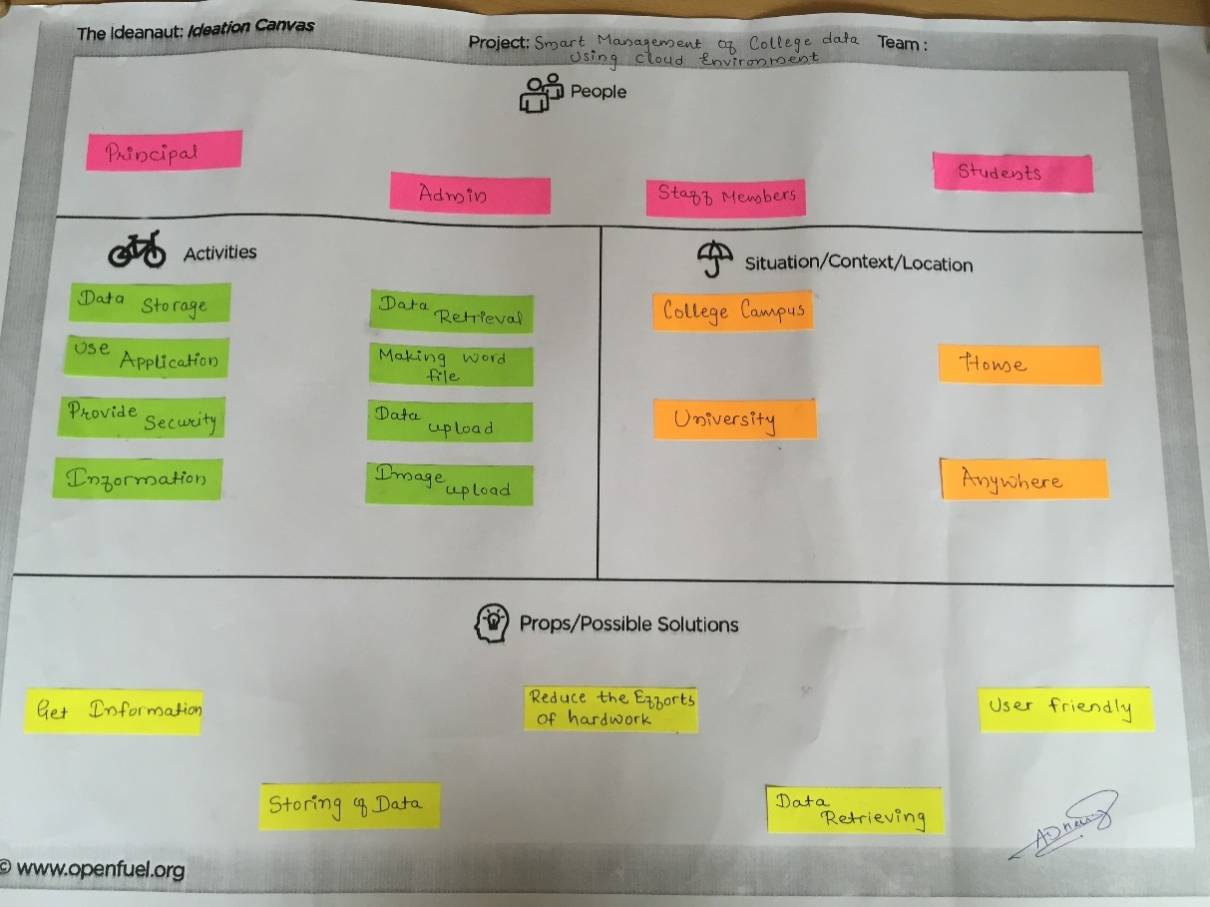

* 1. **Empathy Mapping Canvas**

**Users: Version: 1.0**

1. Students

2. Staff members

3. Admin

**Activities**: **Stakeholders:**

1. Make own Ppt. 1. Admin
2. Making word file 2. Cloud designer
3. Storing data 3. Programmer
4. Provide security
5. Data upload
6. Retrieve data
7. Upload images
8. Information

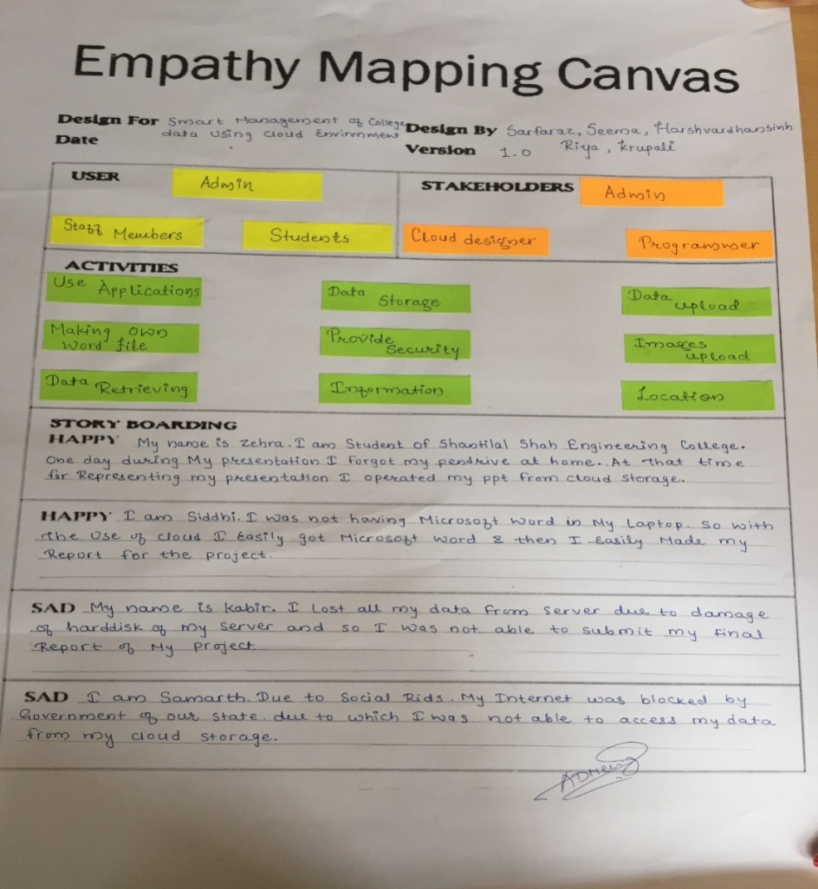

* 1. **AEIOU canvas**
     1. **Activity sheet:**

**General Impression:**

People, Student, Staff Access data online from anywhere, store and retrieve.

**Features:**

1. Automatic Backups

2. File archiving

3. File sharing

4. Remote access

5. Open file Backups

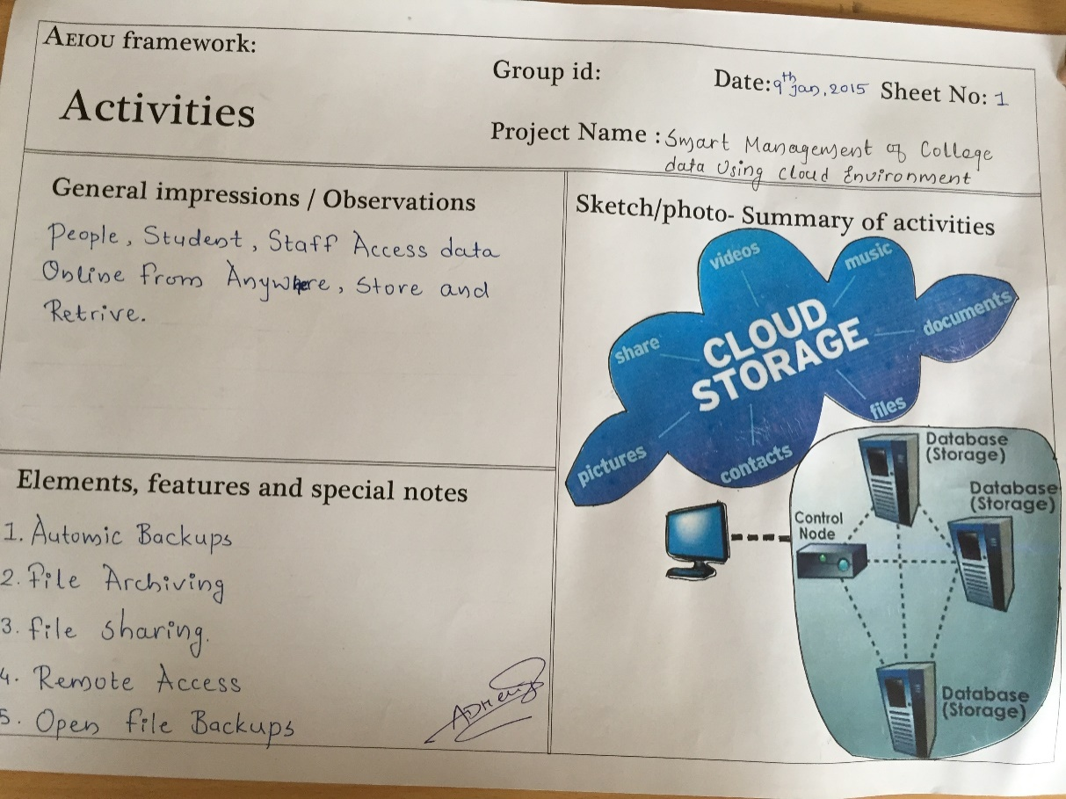

* + 1. **Environment Sheet:**

**General impression:**

Person, Student, Staff Access data from college or outside college environment.

**Features:**

Person, Student, Staff Access and Store the data in secure environment.

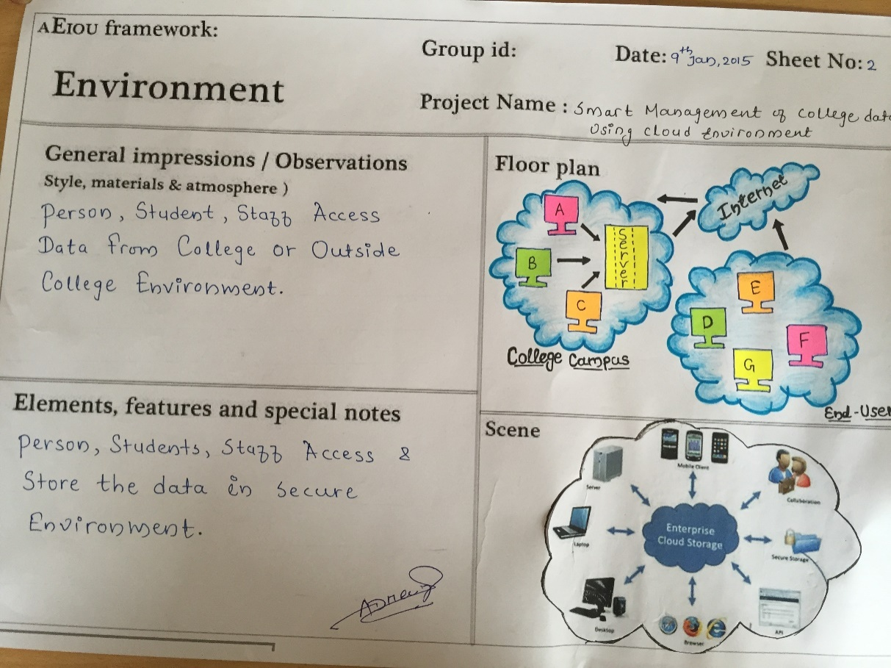

* + 1. **Interactions Sheet:**

**General impression:**

**Students**

**Data Storage**

**People Object**

**Faculty**

**(Cloud Storage)**

**Features:**

Multiple users can interacts with admin and admin can interact with multiple users using cloud storage.

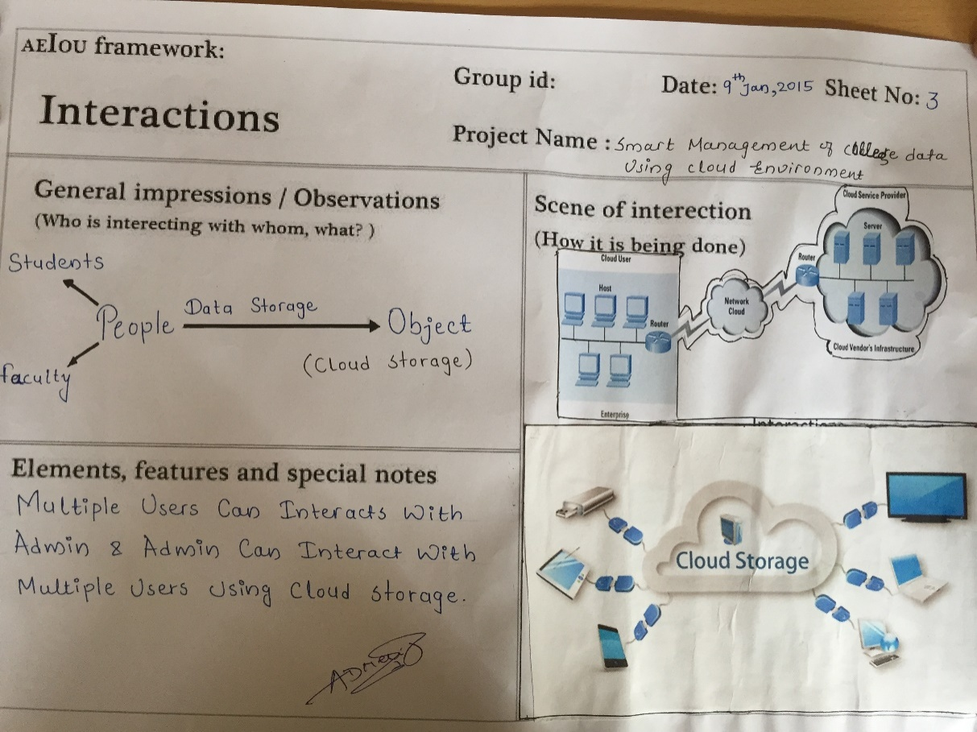

* + 1. **Objects Sheet:**

**General impression:**

1. Server High server and low server
2. Hard disk Memory Storage
3. Software
4. Hardware
5. Internet

**Features:**

Hard disk is a special device Use to store the large amount of data.

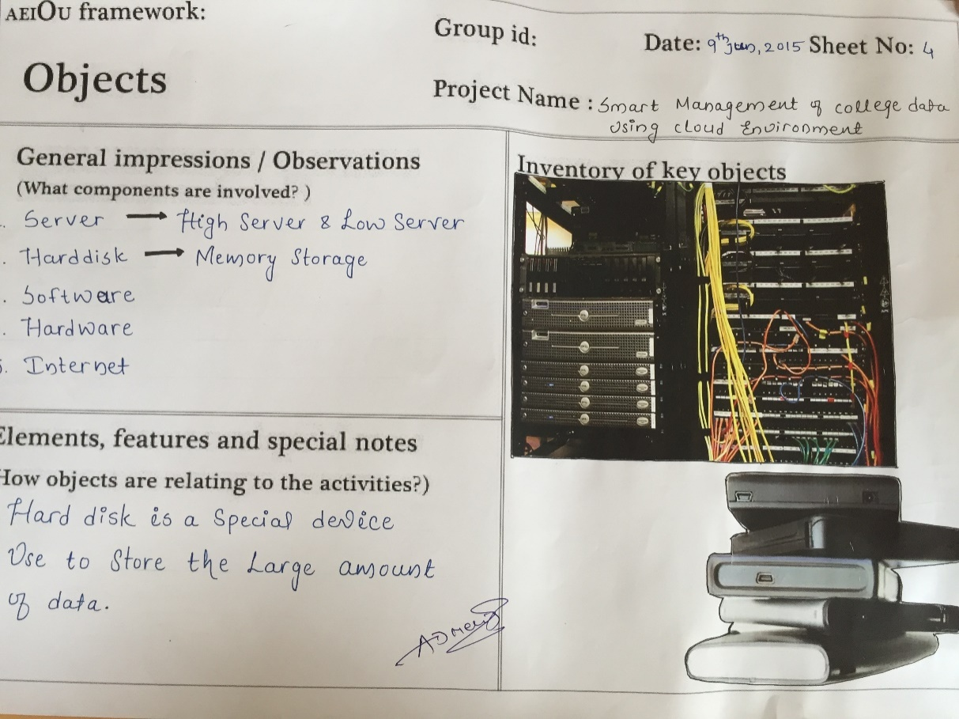

* + 1. **Users Sheet:**

**General impression:**

For implementation of cloud storage the present role is admin, and admin has all rights to access the data and allow all sub-users

**Features:**

1. Admin
2. Students
3. Staff
4. Faculty Members
5. End users

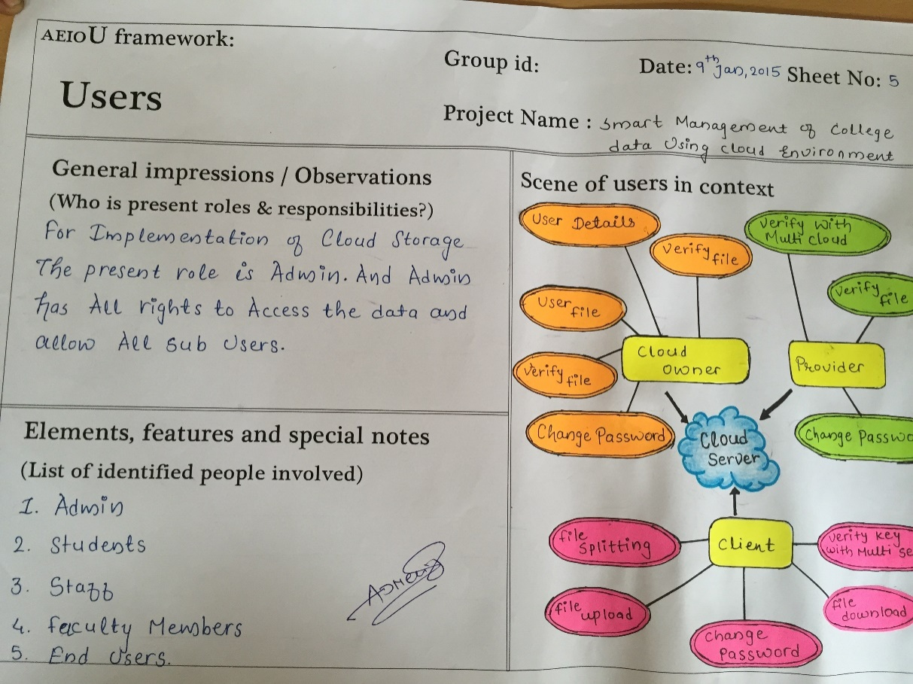

* 1. **Learning Need Matrix (L.N.M.) Sheet**

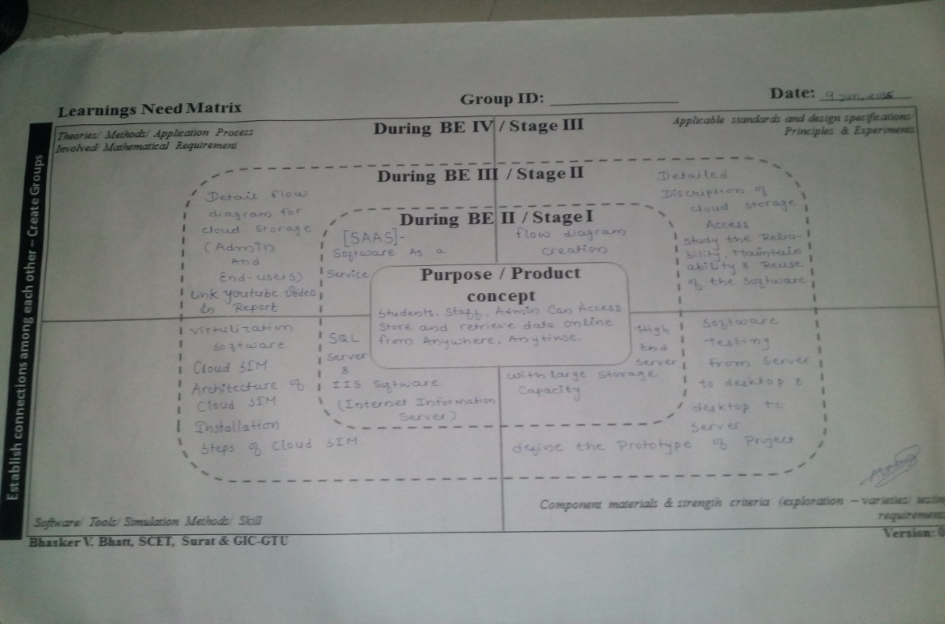

1. **Design Considerations for Detail Design Part**

**4.1 Feasibility Study**

Feasibility is the measure of how beneficial or practical the development of the system will be to the organization. It is a preliminary survey for the systems investigation. It aims to provide information to facilitate a later in-depth investigation.

Feasibility studies aims to objectively and rationally uncover the strength and weakness of the exiting or proposed venture, opportunities and threats as presented by the environment, the resource required to carry through, and ultimately the prospect for success. In its simplest term, the criteria to judge feasibility are **cost** required and value to be attained.

Having gone through all measures of feasibility we report to the management to figure out if the objectives of the new system are met. If and when the objectives of the system are met and the new system is approved, then the more specific details in the proposal should be considered and approved.

**Feasibility Considerations:-**

There are various measures of feasibility that helps to decide whether a particular project is feasible or not.

These measures include: -

* **Technical Feasibility**
* **Operational Feasibility**
* **Economic Feasibility**

**Technical Feasibility:**

Technical Feasibility tries to answer the following question to make the software feasible to develop.

* Can the work for the project be done with current equipment?
* Existing software technology and available personal?
* If new technology is project must be undertaken?
* The compatibility amongst software exits or not?
* Developers aware of these technologies?
* What about the alternate of these chosen technologies?
* **The mention work is feasible for technical feasibility.**

**Operational Feasibility:**

Operational feasibility measure how well the solution will work in the organization and hoe will end user and management feels about system. Proposed system useful to the Govt .Office, personal Companies, Security based companies. It will allow them to query them to get the appropriate and adequate information.

Operational feasibility is measures of how well a proposed system solve the problems, and take advantage of the opportunities identified during scope definition and how it satisfies the requirement identified in the requirement analysis phase of system development.

Operational feasibility studies are generally utilized to answer the following questions:

* **Process**:-
* How do the end-users feel about a new process that may be implemented?
* **Evaluation**:-
* Whether or not the process within the organization will work but also if it can work.
* **Implementation**:-
* Stakeholder, manager, and end-user tasks.
* **Resistance**:-
  + Evaluate management, team, and individual resistance and how that [resistance will be handled](http://www.brighthubpm.com/change-management/34940-overcoming-resistance-ignorance-and-denial-in-change-management/).
* **In-House Strategies:-**
  + How will the work environment be affected? How much will it change?
* **Adapt & Review:-**
  + Once change resistance is overcome, explain how the new process will be implemented along with a review process to monitor the process change.
* **The mention work is feasible for operational feasibility.**

**Economic Feasibility:**

Are there sufficient benefits in creating the system to make the cost ACCEPTABLE? Or, are the costs of not creating the system so great that the project must be undertaken.

Economic feasibility is the most frequent used method for evaluating the effectiveness of a new system. More commonly known as cost/benefits analysis, the procedure is to determine the benefits and saving that are expected from a candidate system and compare them with costs. If benefits outweigh costs, then the decision is made to design and implement the system. An entrepreneur must accurately weight the cost versus benefits before taking an action.

Economics feasibility adders to the following issued:-

* Is the Organization having the suitable budget for developing the proposed System?
* How much advantages can be earned from the system by the organization?
* Would it be cost effective to develop the system or it is the worthwhile to remain with this system?
* **The mention work is feasible for operational feasibility.**
  1. **Design for Performance, Safety and Reliability**

**[A] Performance:**

The performance of cloud storage services depends on two main factors: the network that moves the data between us and the end user, and the performance of the storage service itself.  
  
 **1. Network**  
When you make a request to Cloud Storage, one of the key determinants of performance is the network path between you and our servers. This path is critical because if the network is slow or unreliable, it doesn’t really matter how fast the backend is.  
  
There are two main ways to make the network faster:

* Serve the request from as close to the user as possible
* Optimize the network routing between the end-user and the service, including avoiding pockets of network congestion and minimizing the number of network hops between the user and the service

**2.Storage**  
The other component of system performance is how quickly our servers process your reqest. The data needs to be managed optimally and once an end-user’s request reaches our servers, we need to serve the request as fast as possible. In a sense, Cloud Storage is a gigantic filesystem: authorization checks need to happen, the object in question needs to be looked up, and the data requested needs to be read from the physical storage medium and transferred to the end user, all as efficiently as possible.

**[B] Safety:**

To keep data secure, the front line of defence for any cloud system is encryption. Encryption methods utilize complex algorithms to conceal cloud-protected information. To decipher encrypted files, would-be hackers would need the encryption key. Although encrypted information is not 100% uncrack able, decryption requires a huge amount of computer processing power, forensic software, and a lot of time. Can it be done? Yes, the only way to keep your data safe for certain is to lock it up in a safe beneath the ground. That being said, your cloud-stored data is generally safer than your locally stored data. Cloud services utilize more complex security methods than the average computer owner is able to devise, giving your cloud-stored data an added level of protection.

**[C] Reliability:**

Cloud storage is much more reliable when used in tandem with another storage system. As stated earlier, the biggest concern with cloud storage is lost data, not hacked data. But that issue is eliminated if the cloud is used more as a “sharing” platform instead of a “storage” platform. By taking shared files and storing them into something like Google Drive, you can ensure that if your data is lost, you can easily locate it through the other platform.

* 1. **Design for Ergonomics and Aesthetics**

**Ergonomics:**

|  |  |  |
| --- | --- | --- |
| **Criteria** | **Sub-Criteria** | **Description** |
| **Usability**  Usability | Ease when accessing | We are allowing easy access of data from inside the college environment as well as outside the college environment. |
| Location | The visitor can be able to locate where he is on the cloud at all times. Moreover, our logo is in the same spot on all the pages and a uniform graphic charter applied to all of the pages to let the user know that he is still on our cloud. |
| Freedom when Accessing | Our cloud gives the possibility to return to the home page and the main headings with one simple click, no matter what page user is on. |
| Address Visibility | The page's URL is visible and sufficiently clear to allow users to know where they are and easily return to that page. |
| Tangibility of the Information | The information on the cloud is qualified, i.e. information such as the date of the last update. |
| Structure Homogeneity | The elements used for browsing is located at the same spot on every page and has the same presentation from one page to another. |
| **Speed**  Speed | Loading Time | A page's loading time is short as possible. |
| Optimized Images | Our idea to optimize image size as much as possible by choosing a well-adapted format and the fewest of colors possible. |
| **Interactivity**  Interactivity | Segmenting Information | In order to allow visitors to take in information more easily and, in some cases to pique curiosity, segment information is added in website. |
| **Adaptability**  Adaptability | Adaptability | User can personalize a website through user intervention. |
| Font Resizing | A cloud’s text preferably not use fonts whose sizes are not expressed in absolute value. User can resize the font if they so desire. |

**Aesthetics:**

|  |  |  |
| --- | --- | --- |
| **Criteria** | **Sub-Criteria** | **Description** |
| **Soberness**  Soberness | Simplicity | Our cloud is very simple that everyone is able to use It easily. |
| Not Overloaded | Animated images are not recommended. Only simplified college documents and data is allowed. |
| **Legibility**  Legibility | Clearness | The fact that written information is harder to read on screen than on paper (25% more reading time) should be taken into account. Thus, the text should be sufficiently spaced out. |
| Structuring | The text should be structured by paragraphs and titles at different levels in order to facilitate reading. |
| Layout | The different pieces of information must be organized by level of importance. The most important pieces of information must appear at the top of the page. |

**4.4 Design for Manufacturability and Analysis (DFMA)**

Cloud manufacturing is a type of parallel, networked, and [distributed system](https://en.wikipedia.org/wiki/Distributed_system) consisting of an integrated and inter-connected virtualized service pool (manufacturing cloud) of manufacturing resources and capabilities as well as capabilities of intelligent management and on-demand use of services to provide solutions for all kinds of users involved in the whole lifecycle of manufacturing.

Private cloud refers to a centralized management effort in which manufacturing services are shared within one company or its subsidiaries. Enterprises' mission-critical and core-business applications are often kept in a private cloud.

**4.5 Design for cost, environment**

**Cost:**

For establishing **High-end server** estimate cost require is 350000Rs Components used to establish high end server is:

**Memory**: 16 GB SMART RACK 42U

**Hard disk**: 2 TB, 2 NOS

**Operating system**: WIN 2012 STANDARD 64 BIT,

**Processor**: 2ND PROCESSOR (2.2GHZ/6 CORE/15MB/80W)

For establishing **Low-end server** estimate cost require is 175000Rs Components used to establish low end server is:

**Memory:** 8 GB SMART RACK 42U

**Hard disk:** 1 TB,

**Operating system:** WIN 2012 STANDARD 64 BIT,

**Processor:** 2ND PROCESSOR (2.2GHZ/6 CORE/15MB/80W)

1. **Design Calculation**

**Data flow diagram (DFD)**

**DFD context-Level: 0**

Server

DBA

Store data on server

Stored data are handled by admin

Access and use data

Registration, login, upload file

Client

**DFD context level: 1**

**6. Measuring instruments/techniques-knowledge and use**

Log-in

DBA

Log-in respond

Log-in

Give facilities to DBA by system

Data send to browser if ID is correct

Request ID send to cloud storage

Connect client and server

Control, retrieve, and send process

Respond to browser

Request for send or retrieved data

Respond to authenticate user

Authenticate User ()

Student

Or faculty

Server

User/Staff

**Private cloud:**

Many companies are already virtualizing their IT environment an have been doing so for years. Initially, virtualization was deployed for compute resources, primarily as a cost-saving technology.

Organizations soon recognized that virtualization provided additional cost-savings benefits as well as enhanced speed and flexibility. Most clouds are built on virtualized infrastructure technology. Cloud computing originated as a new way to deliver IT services by providing a customer interface to automated, self-service catalogues of standard services, and by using auto scaling to respond to increasing or decreasing user demand. From an IT perspective, a private cloud offers the key advantages of speed, agility, and efficiency while maintaining control of sensitive workloads.

**Virtualization and private cloud:**

The path from virtualization to a self-service cloud poses technical as well as organizational challenges related to management and operational processes, culture, and politics. The following five high-level actions serve as a framework to help you understand and successfully address the organizational and technology issues you will face. Many of the specific activities involved will take place simultaneously. Neglecting any one of these can trip you up and cause your project to fail.

**•Step 1:** Develop a cloud strategy – Establish where you want to go.

**•Step 2:** Manage organizational and business process change – Get the business on board.

**• Step 3:** Organize IT around services delivery – IT shifts it role to a broker of cloud services.

**•Step 4:** Put the right technology in place – Set short-, medium-, and long-term goals.

**•Step 5:** Manage and monitor your cloud and manage with data- Use analytics to improve operation.

**7.Comparison between existing cloud and our cloud**

As per our knowledge there is not any government institute or government organization that is using this type of data storage and data retrieval. So we are preparing a small private cloud storage for our institute.

**7.1 Selecting material**:

1. Hard-disk
2. Server
3. Large data storing device, e.g. hard-drive

**7.2 Tools and equipment’s for our project**:

1. Automatic Backups

2. File archiving

3. File sharing

4. Remote access

5. Open file Backups

**8.Analysis**

There are many clouds which are available in market from which some are well known and we have analysed the features of that clouds, they are as follow.

1. Google drive
2. Sky drive
3. Amazon
4. IBM

By following the features of this cloud we are trying to make our own private cloud for our college including the features like as follow:

1. Automatic Backups

2. File archiving

3. File sharing

4. Remote access

5. Open file Backups

1. **Prototyping & Testing**

**9.1 Prototyping**

**9.1.1 Cloud SIM**

Cloud Simis a framework for modeling and simulation of [cloud computing](https://en.wikipedia.org/wiki/Cloud_computing) infrastructures and services. Originally built primarily at the Cloud Computing and Distributed Systems (CLOUDS) Laboratory.

**9.1.2 Cloud Sim Architecture**

The Cloud Sim simulation layer provides support for modeling and simulation of virtualized

Cloud-based data center environments including dedicated management interfaces for VMs,

memory, storage, and bandwidth.

This layer also exposes the functionalities that a Cloud application developer can extend to perform complex workload profiling and application performance study. The top-most layer in the Cloud Sim stack is the User Code that exposes basic entities for hosts (number of machines, their specification, and so on), applications (number of tasks and their requirements), VMs, number of users and their application types, and broker scheduling policies.

Cloud application developer can perform the following activities:

1. generate a mix of workload request distributions, application configurations.
2. model Cloud availability scenarios and perform robust tests based on the custom configurations.
3. implement custom application provisioning techniques for clouds and their federation.

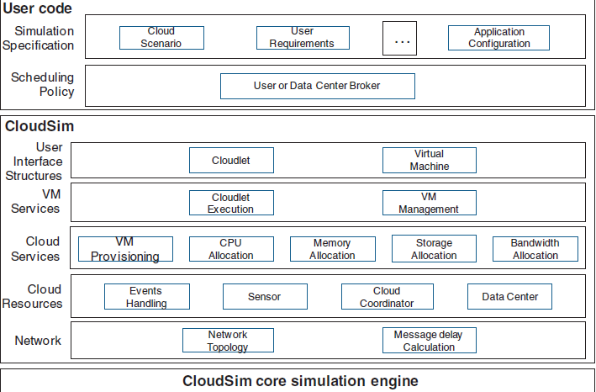

**Fig:** Layered Cloud Sim Architecture

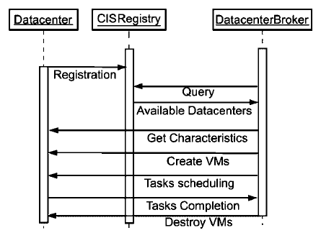

**Fig:** Simulation Data Flow Diagram

## 9.1.3 Features of cloud SIM

* support for modeling and simulation of large scale Cloud computing data centers
* support for modeling and simulation of virtualized server hosts, with customizable policies for provisioning host resources to virtual machines
* support for modeling and simulation of energy-aware computational resources
* support for modeling and simulation of data center network topologies and message-passing applications
* support for modeling and simulation of federated clouds
* support for dynamic insertion of simulation elements, stop and resume of simulation
* support for user-defined policies for allocation of hosts to virtual machines and policies for allocation of host resources to virtual machines.

### 9.1.4 How to Install Cloud Sim in Windows

**Step 1: Setting up the Prerequisites**  
  
**1.** First of all we need to download the Cloud Sim and latest version of the Java Development Toolkit (JDK). These can be found here:

[Cloud Sim 3.0.3](https://adf.ly/t2jfl) [JDK latest version for Windows](https://adf.ly/szMZ3)

**2.** Cloud Sim requires a working JRE, so install the JDK.  
  
**3.** Now its time to install the Cloud Sim. Unpack the downloaded 'CloudSim-3.0.3.tar.gz' or 'CloudSim-3.0.3.zip' .

**Step 2: Setting up the Environment**

**1.** The first path to be set is the 'Path' variable which will contain the location of executable java files such as 'javac' and 'java' and will be used by the Cloud Sim while compiling and running a Cloud Sim or Java program.

### 2. The second path to be set is the 'CLASSPATH' variable which will contain the location of the class files and will be used by the Cloud Sim while executing an application.

|  |  |  |
| --- | --- | --- |
|  | **Variable name** | **Variable value** |
| **1** | Path | C:\Program Files\Java\jdk1.8.0_11\bin; |
| **2** | CLASSPATH | C:\Program Files\Java\jdk1.8.0_11\bin; C:\Users\Dhyan\Desktop\cloudsim-3.0.3\jars\*; C:\Users\Dhyan\Desktop\cloudsim-3.0.3\examples; |

**Step 3: Testing the Setup (Compiling and Executing a Cloud Sim Application)**

1. **Compiling a program:** If you have followed this DIY then compiling a Cloud Sim program is pretty straightforward; the basic syntax for compilation is just similar to that of Java programs.

|  |  |
| --- | --- |
| 1 | JavacC:\Users\Dhyan\Desktop\cloudsim-3.0.3\examples\org\cloudbus\cloudsim\examples\CloudSimExample1.java |

1. **Running the compiled program:** The syntax for running a compiled Cloud Sim program is similar to that of running a program in Java i.e. java filename. In our case we have to type

|  |  |
| --- | --- |
| 1 | java org.cloudbus.cloudsim.examples.CloudSimExample1 |

**9.1.5 Virtualization**

Virtualization is the creation of a virtual (rather than actual) version of something, such as an operating system, a server, a storage device or network resources. Operating system virtualization is the use of software to allow a piece of hardware to run multiple operating system images at the same time.

**Full Virtualization**

Red Hat Enterprise Linux contains virtualization packages and tools which provide system administrators with the means to run fully virtualized, unmodified, operating system guests on Red Hat Enterprise Linux. This provides companies with the ability to consolidate older systems onto newer, more efficient hardware. This reduces physical space and operating costs involved with powering and cooling older, less efficient systems. Full virtualization incurs worse I/O performance than native, also known as bare-metal, installations of operating systems.

**[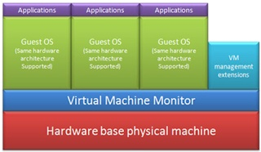](http://3.bp.blogspot.com/-SpYDVouuZjo/UMNaR5uqjnI/AAAAAAAAAug/HjlCT53dRqE/s1600/Untitled.png)**

**Full-virtualization environment**

**Benefits:**

* Ability to consolidate servers
* High availability service
* Mirrored resources that are allocated to the server are always available
* Built in load balances to ensure quality of service
* Fault tolerance available for single CPU servers to offer zero downtime
* Boot time is minimum based on technology
* Supports all software, does not require "virtual" version
* Software is not tied to or dependent on the hardware

**Uses:**

* Dedicated servers can be put into a virtual environment
* Applications, intranets, websites or nearly anything that is stored on a server and may talk to other servers

**9.2 Cloud Testing**

**[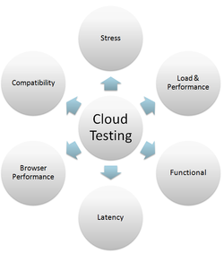](https://en.wikipedia.org/wiki/File:Types_of_testing_in_cloud.png)**

**[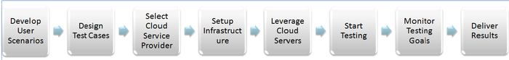](https://en.wikipedia.org/wiki/File:Steps_in_cloud_testing.png)**

**9.2.1 Keys for Successful Testing**

**1.** Understanding a platform provider's elasticity model/dynamic configuration methods.

**2.** Staying abreast of the provider's evolving monitoring services and [Service Level Agreements](https://en.wikipedia.org/wiki/Service_Level_Agreement) (SLAs).

**3.** Potentially engaging the service provider as an ongoing operations partner if producing [commercial off-the-shelf](https://en.wikipedia.org/wiki/Commercial_off-the-shelf) (COTS) software.

**4.** Being willing to be used as a case study by the cloud service provider. The latter may lead to cost reductions.

**10.Detail Design Calculation**

**10.1 Material Requirements:**

### 1. Compute Resources

### 2. Selecting the Storage Solution

### 3. Network Services Implementation

### 4. Network Virtualization Technology

### 5. Network Infrastructure

**10.2 Standards:**

**1. Cloud design standards for interoperability and portability**

Cloud interoperability allows seamless exchange and use of data and services among various cloud infrastructure offerings and to use the data and services exchanged to enable them to operate effectively together.

Cloud portability allows two or more kinds of cloud infrastructures to seamlessly use data and services from one cloud system and be used for other cloud systems.

**2. Cloud design standards for security**

Securing the information systems and ensuring the confidentiality, integrity, and availability of information and information being processed, stored, and transmitted are particularly relevant as these are the high-priority concerns and present a higher risk of being compromised in a cloud computing system.

**3.Cloud design standards for performance**

performance includes considerations related to monitoring, reporting, measuring, scaling, and right-sizing cloud resources to meet the expected or experienced demand. This area deserves careful consideration, as it relates directly to the factors that control the potential cost savings to the government from the use of cloud computing.

**4. Cloud design standards for service agreements**

**5. Cloud design standards for accessability**

Accessibility is relevant to cloud computing services at the application level where a human interacts with an application. This is where accessibility is measured.

**10.3 Safety Rules**

# ****1. Password First.****

If we are talking about ideal scenarios, then your username and password should be unique for every service or site you have to use credentials for. The reason is simple enough: if one gets compromised, so do the rest of your accounts.

# ****2. Security Question, Check****.

Try your best to avoid questions to which answers can be found just by taking one glance online, for instance, on your Face book profile. Best way to go about this is to choose a question and answer it with another question’s answer. For instance if you choose the question where did you live as a kid, answer with ‘yellow’.

# ****3. Try Out Encryption****.

Whenever this is possible, this is a great idea. Encryption software does require some effort on the part of the user but it will also scramble and code your credentials so that no one will be able to procure them easily.

# ****4. Manage Passwords.****

By this time you will have a lot of passwords and usernames to be tracking and taking care of. So to manage this get your hands on an app or software that will do this for you. A great option is the Last Pass utility.

# ****5. Two Factor Authentication.****

This means that there are two modes which are being used by the site before allowing the user entry. So instead of just username and password, a unique code will also be required which is available through a text message to your phone at the time of log in. This way even if someone gets your credentials, they won’t have the unique code and hence access will be denied.

# ****6. Don’t Think, Just Backup.****

It may be strange to be told to backup data on a physical drive when it comes to securing [cloud computing](http://cloudtweaks.com/) data, but that is what you need to do. This is why you shouldn’t think over it; you should simply backup your data on an external drive and keep it with you.

# ****7. Delete When Done.****

Again, why bother deleting anything when there are limitless data storage options around? The reason is that you never know how much data can later become potentially dangerous for you. If an e-mail or a warning message from some bank account has outlived its worth, simply delete it.

# ****8. Be Careful Where You Log In.****

Many times we end up logging in from devices other than our own. And of course we tend to forget that these other devices may be saving our information via web browsers.

**9. Use Anti-Virus and Anti-Spy Software.**

The reason for this, despite having to do with cloud data, is that all the access to the cloud is from your system first. Hence if your system is at risk, so is your online data. If you forget to encrypt then a key logger may get to your cloud vendor password and hence all may be lost anyway.

**11.Design for Use, Reuse and Sustainability**

**11.1 Sustainability:**

**1.** Resource constraints

**2.** Ever increasing demand leading to higher unit costs

**3.** Concerns over the environmental impacts of electricity generation

**4.** The need to invest in electricity infrastructure to continue to supply the increasing demand

**5.** Legislation to improve air quality and regulate utilities

* 1. **Maintainability:**

It basically defines that how easy it is to maintain the system. This means that how easy it is to analyze, change and test the application or product.

**1.Corrective maintenance –** Correcting problems. The maintainability of a system can be measured in terms of the time taken to diagnose and fix problems identified within that system.

2.**Perfective maintenance –** Enhancements. The maintainability of a system can also be measured in terms of the effort taken to make required enhancements to that system.

**3.Adaptive maintenance –** Adapting to changes in environment. The maintainability of a system can also be measured in terms on the effort required to make required adaptations to that system.

**4.Preventive maintenance –** Actions to reduce future maintenance costs. This refers to actions to reduce future maintenance costs.

**11.3 Reusability:**

Reusability process model for cloud computing platform and name it **Cloud Computing Reusability** (CCR) Model . A model capable of developing cloud based applications with reusability by retrieving the components from the cloud component repository by using pattern matching algorithms and various retrieval methods.

**11.4 Reliability:**

Cloud storage is much more reliable when used in tandem with another storage system. As stated earlier, the biggest concern with cloud storage is lost data, not hacked data. But that issue is eliminated if the cloud is used more as a “sharing” platform instead of a “storage” platform. By taking shared files and storing them into something like Google Drive, you can ensure that if your data is lost, you can easily locate it through the other platform.

**12.Video prototype**

**12.1 Cloud Sim Installation Process**

[http://www.youtube.com/watch?v=iZmdQEjW]

**13. Conclusion**

After careful observation, we have concluded that by creating our own private cloud for our college we are reducing the hard work and efforts of students and staff members. By doing this we can save the confidential and important data of our college.

**14. References**

[1]   ["A History of Cloud Computing"](http://www.computerweekly.com/Articles/2009/06/10/235429/A-history-of-cloud-computing.htm). Computer Weekly.

[2]   Michael F. Lewis (March 29, 2013). ["Move over Al Gore, Kurt Vonnegut invented the internet"](http://michaelflewis91.wordpress.com/2013/03/29/move-over-al-gore-kurt-vonnegut-invented-the-internet/). Word press.

[3] Louden, Bill (September 1983). "Increase Your 100's Storage with 128K from CompuServe". Portable 100 (New England Publications Inc.) (Volume 1, Number 1): 22.[ISSN](https://en.wikipedia.org/wiki/International_Standard_Serial_Number) [0738-7016](https://www.worldcat.org/issn/0738-7016).

[4] Daniela Hernandez (May 23, 2014). ["Tech Time Warp of the Week"](http://www.wired.com/2014/05/tech-time-warp-cloud-is-born/). Wired.

[5] ["Box.net lets you store, share, work in the computing cloud"](http://www.bizjournals.com/sanjose/stories/2009/12/07/focus9.html). Bizjournals.com. December 6, 2009. Retrieved17 June 2015.

[6] ["On-premises private cloud storage description, characteristics, and options"](http://www.vion.com/capacity-services/vion-capacity-services.html).

[7] S. Rhea, C. Wells, P. Eaton, D. Geels, B. Zhao, H. Weatherspoon, and J. Kubiatowicz, Maintenance-Free Global Data Storage. IEEE Internet Computing, Vol 5, No 5, September/October 2001.

[8] [A Cloud Environment for Data-intensive Storage Services](http://dx.doi.org/10.1109/CloudCom.2011.55)

[9] Buyya R, Ranjan R, Calheiros RN. Modeling and simulation of scalable Cloud computing environments and the Cloud Sim toolkit: Challenges and opportunities. *Proceedings of the Conference on High Performance Computing and Simulation* (HPCS 2009), Leipzig, Germany. IEEE Press: New York, U.S.A., 21–24 June 2009; 1–11.

[10] VMWARE. Virtualization Overview. [www.vmware.com](http://www.vmware.com).

[11] A. Tomer, et al., "Evaluating software reuse alternatives: A model and its application to an industrial case study," IEEE Transactions on Software Engineering, vol. 30, pp. 601-612, 2004.

[12] Legrand A, Marchal L, Casanova H. Scheduling distributed applications: The Sim Grid simulation framework. *Proceedings of the Third IEEE/ACM International Symposium on Cluster Computing and the Grid*, Tokyo, Japan, 2003; 138–145.

[13] Smith JE, Nair R. *Virtual Machines*: *Versatile Platforms for Systems and Processes*. Morgan Kaufmann: Los Altos, CA, 2005.

[14] www.youtube.com